CS 255 System Design Document Template

UML Diagrams

UML Use Case Diagram

UML Activity Diagrams
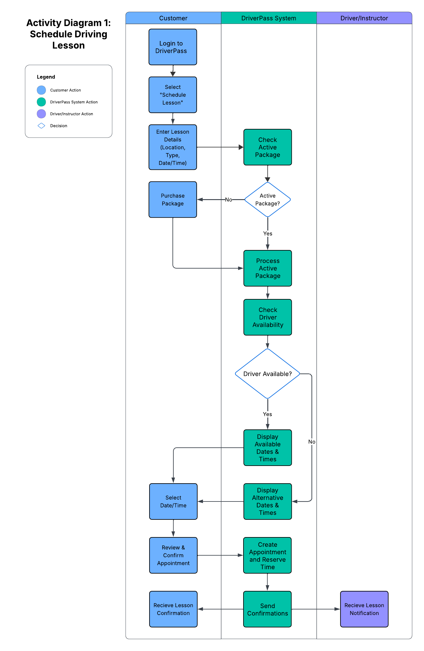
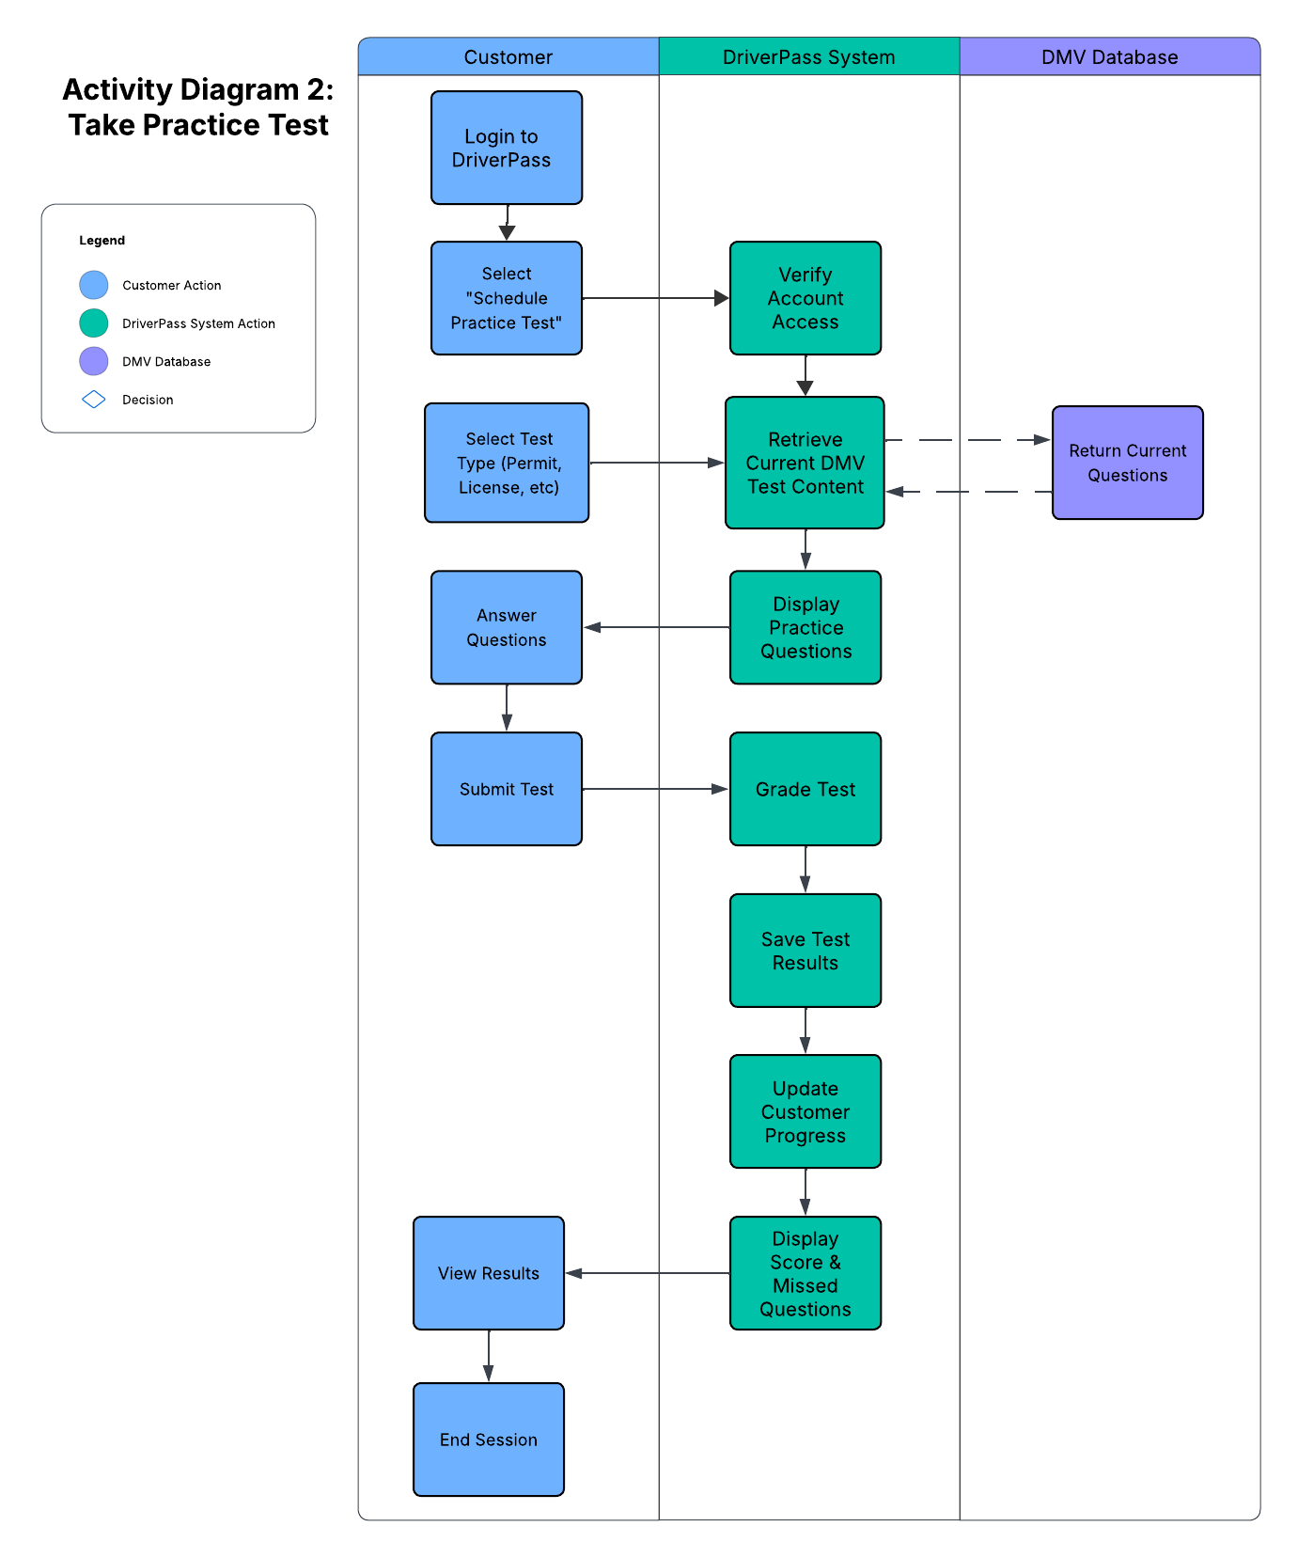

UML Sequence Diagram
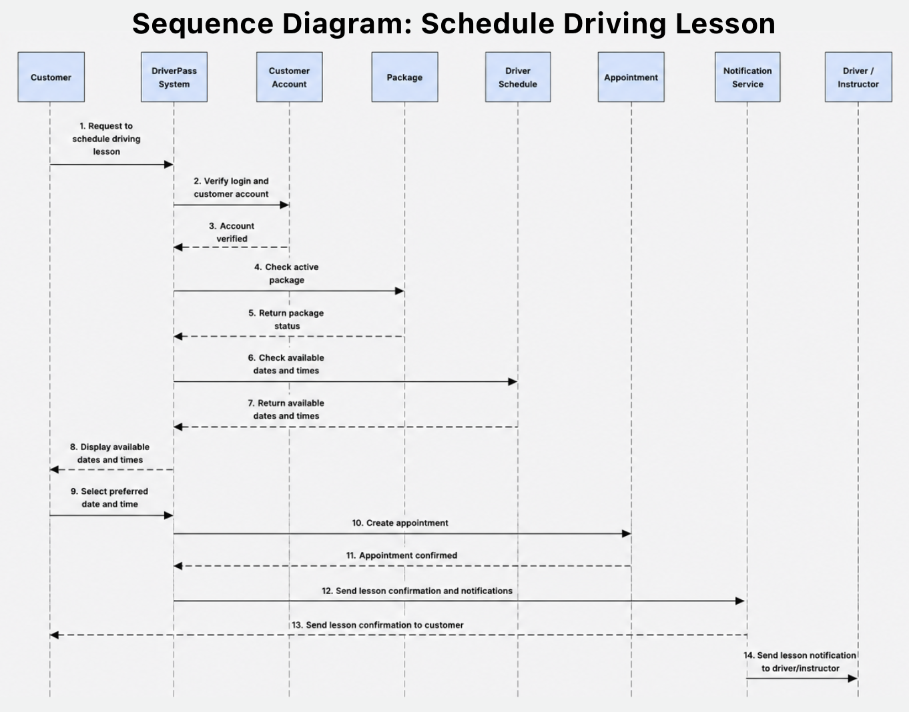

UML Class Diagram
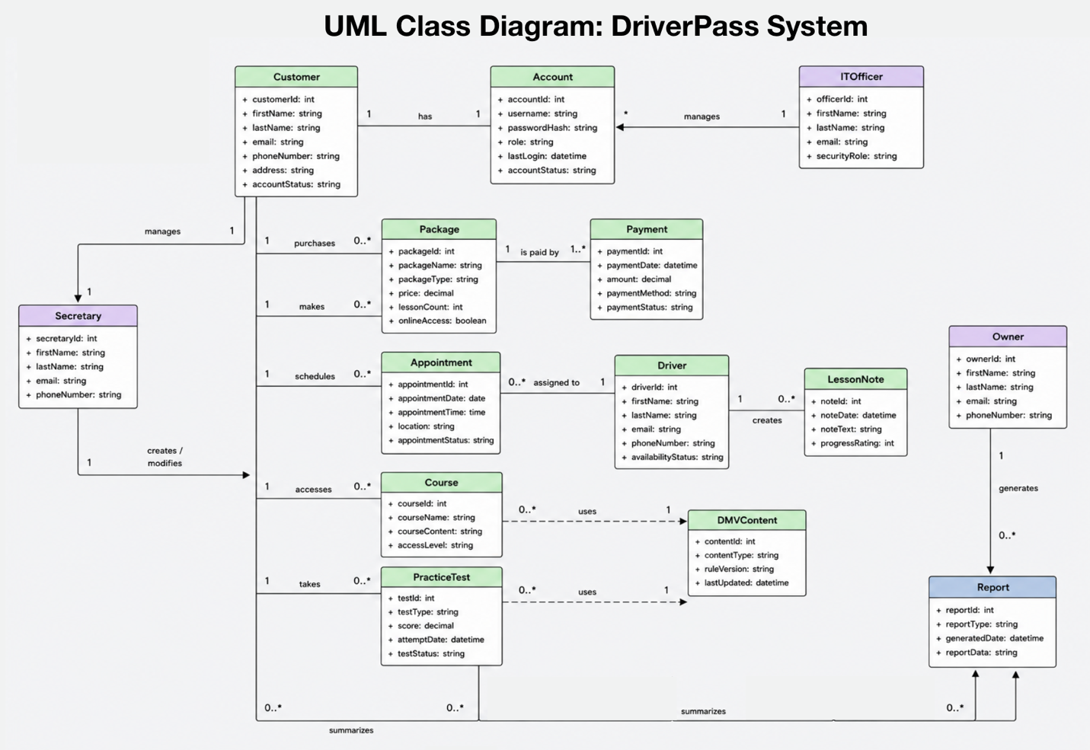

Technical Requirements
The DriverPass system will be a web-based application that allows customers to purchase training packages, schedule driving lessons, access online training materials, take practice tests, and track their progress toward passing the DMV exam. Based on the system design diagrams, the system must support multiple user roles, including customers, secretaries, drivers, the owner, and the IT officer. Each role requires different permissions and access levels to perform specific tasks within the system.

For hardware requirements, DriverPass will need reliable desktop computers or laptops for office staff, mobile devices for drivers who need access to lesson schedules, and secure servers or cloud-hosted resources to store application data. Customers must have access to a computer, tablet, or smartphone with an internet connection in order to use the online features of the system. A stable network connection is required to support lesson scheduling, online course access, practice testing, and payment processing.

For software requirements, DriverPass will need a web application that can be accessed through standard web browsers, a database management system to store system data, authentication software to manage user accounts, payment processing services for package purchases, and notification services to send appointment confirmations and reminders. The database must store customer accounts, training packages, payments, appointments, driver schedules, lesson notes, practice test results, online course content, DMV information, and generated reports. The system must also support role-based access controls so that users only have access to information related to their responsibilities.

Several tools and services are required to support the system. These include secure payment processing tools, email or notification services for appointment updates, reporting tools for management functions, and mechanisms for maintaining current DMV rules and testing information. Since DriverPass relies on accurate DMV content, the system must be able to update or synchronize practice test questions and training materials whenever DMV information changes.

The system infrastructure must support secure communication between all users and the DriverPass application. Data should be transmitted using encrypted connections, and regular backups should be performed to protect customer records, payment information, appointment schedules, lesson notes, and test results. The infrastructure should also provide sufficient performance to support multiple users accessing the system simultaneously without significant delays.

Security is one of the most important technical requirements for DriverPass. Customer information, login credentials, payment data, lesson schedules, and test results must be protected through password encryption, secure payment processing, role-based permissions, and secure network connections. The IT officer will be responsible for managing user accounts, maintaining security settings, and monitoring the system for potential issues.

Several assumptions were made during the design process. It is assumed that customers will have reliable internet access and a compatible device to access online training materials, schedule lessons, and complete practice tests. It is also assumed that current DMV information will be available for updates and that users will maintain accurate account information within the system.

Several limitations may affect the system. DriverPass depends on third-party services for payment processing, notifications, hosting, and DMV content updates. If any of these services experience outages, delays, or technical problems, certain system functions may be temporarily unavailable. In addition, customers without reliable internet access may have difficulty using online features. DriverPass should address these limitations through regular maintenance, system monitoring, backup procedures, and support processes to ensure reliable service for all users.

